28.48: (a) 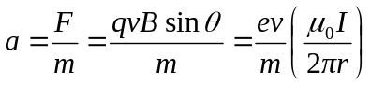
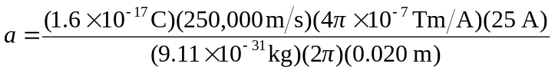
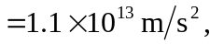away from the wire.

b) The electric force must balance the magnetic force.

eE = eVB
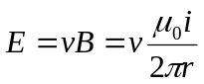
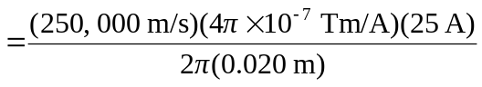
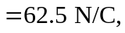 away from the wire.

(c)
